Ohio Southern Baptist Churches helping their communities during the COVID 19 Pandemic:

CORONAVIRUS 19 RESPONSE BY OHIO SOUTHERN BAPTIST CHURCHES: March 30, 2020

- Bloom Baptist in Pickerington is working with the Fairfield County Meals on Wheels program and assisting in packing meals and then volunteering to deliver them!
- FBC Vermilion and Good Shepherd Baptist Church have provided meals with Lighthouse Ministries in Lorain last Sunday and this Sunday. Carryout and Delivery.

- FBC Vermilion will be providing a carryout / delivery meal over the next few Saturdays around noon to seniors and others in Vermilion, OH.

- United Faith Community Church, Reynoldsburg, Ohio is doing the following:

  - Financially supporting widows and elderly with medication pick-up, food and supplies (Derwin Hammond and others are making deliveries). We are keeping data of these support efforts and we will forward information at conclusion of services.
  - Starting in April we will provide free diapers and wipes to the Reynoldsburg community.

- First Baptist Church of Groveport is working with the Groveport Madison School District to allow school busses to use the church parking lot to deliver breakfast and lunch meals to children in our area of the district. Also, church members are ministering to each other especially senior members in meeting their daily needs.

- As of right now, Calvary Baptist Church, Blanchester, is continuing with our regular food pantry and awaiting direction from health dept. if so needed. We have made our building available if the need would arise.

- Currently Hillcrest has been connecting with neighbors to offer any assistance needed. Our members are caring for one another with phone calls, meal deliveries, snail mail cards, and etc. We had a request from a local nursing home to send residents encouraging cards since they cannot have visitors right now. We have asked our members to do that, and provided them with the information to make that possible. Other than that, we haven't heard of any requests from our health department more than heeding the directives for the quarantine. Feel free to let us know if we can serve in any way.

- Here is a summary of our COVID-19 related activities for Dover Baptist Temple:
a. We contacted our local health department
b. We are partnering with our local school district to provide 6,000 meals/week for the duration of this crisis
c. We are actively engaging with members especially those who are elderly, high risk, or have lost their jobs to provide groceries, transportation, or other needs.
d. We have been engaging with families in our community who are in need, providing direct assistance when we can and helping them find other means of support when and where we are unable to help.
e. We have moved our services entirely online utilizing a team of 9 who follow the Governor’s COVID-19 protocols.
f. We have begun a daily online Bible study, Mon-Fri. 11:00 AM, through the book of 1 John, to facilitate continued fellowship of our members in the Word.
g. We are preparing for a Drive-In Easter Service utilizing an FM transmitter, which will allow everyone to worship in the safety of their vehicle. We will be observing communion using factory sealed communion sets (Juice and bread in separate sealed compartments), which will be distributed, from the box by individuals with facemasks and gloves who have had a temperature check.
9. In the photo Larry Bays is handing Micki Smith about 300 of their N95 masks and 24 Tyvek suits of different sizes. Larry leads the DR Mud out unit for the Cincinnati Area Baptist Association. Micki is an administrator at the Clermont Mercy Hospital. Micki is also the wife of Jeff Smith who pastors Pleasant Hill Baptist in Milford.
Micki said, “Nurses need a new mask with different patients. And even working with one patient, they can only use them five times. These will really help.”
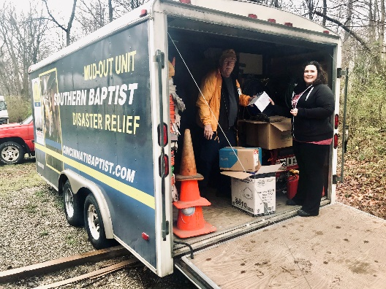

- New Life Mission (North Fairfield Baptist)
  - The mission team met and then everything went crazy. In light of the needs of New Life Mission the Mission Team would like to do the following:
- Give a onetime $1000 gift to New Life
- Increase our monthly gift to New Life by $200 for the next three months, which can be extended based upon the actions and needs of New Life
  - New Life Mission will continue to offer essential services through its food pantry and daily lunches to those in poverty or homeless in the Butler County area. New Life Mission will continue with Lunches to-go from 12:00-1:30pm and food pantry 10:00am -2:00pm Monday-Thursday.
  - They urgently need volunteers in order to continue providing these services, and will provide mandatory masks and gloves. Call Felix at 513-313-2312 for more information or go to www.missionhamilton.org
- Fairfield Community Foundation
  - The Fairfield Community Foundation is taking calls for those in need of assistance. This incredible organization has connections to many other non-profits and has been able to help all who have called.
  - For more information head to https://fairfieldcommunityfoundation.org/
- The Council on Aging
  - The Council on Aging of Southwestern Ohio (COA) is a nonprofit organization dedicated to enhancing quality of life for older adults, people with disabilities, their families and caregivers. They promote choice, independence, dignity and well-being through a range of services that help people remain in their homes for as long as possible.
  - The Council on Aging is looking for Volunteers during the Covid-19 outbreak to shop for seniors, deliver meals, package meals, shelve items in the warehouse, and more. This is a great opportunity for all of us to work together to help the Cincinnati and Dayton area senior citizens.
  - For more information head to https://www.help4seniors.org/
  - Email Jacqueline Hutsell at jhutsell@help4seniors.org to sign up!
- The deacons continue to be in contact with our widows, widowers, shut-ins, and other vulnerable members. They have also created a centralized email so that everyone can contact them with any needs. Please email them at deacons@northfairfield.com if you need anything or know someone who may need support during this time.

- Through your office, we (Cleveland Hope association) were contacted by the Cuyahoga County Office of Emergency Management. They needed volunteers to help at their central collection/sorting facility for donated PPE supplies for healthcare workers and first-responders. We were able to send four volunteers yesterday and some today as well. We are working on building a rotation among our churches to staff this need as it is an ongoing need M-F for the foreseeable future.

- Here’s what Beavercreek Baptist Church is doing:

- Besides taking care of our church members through small groups and deacon connection we are connecting in our community.
- So far, I have contacted our mayor and city council to offer any assistance to meet needs as they arise. We’ve contacted both funeral homes in town, who are on the same street as the church, and offer to livestream funerals. I’ve talked to our county health department to offer to meet needs as they arise.
- We’ve expanded our online services to livestream on our website, Facebook and YouTube. We do Sunday morning 10:30, Wednesday evening 6:30 and Monday at 1:00 as a relationship/communication teaching. Helping people with relationships as they are home all the time. Some of our teachers will join me to livestream help for parents on Homeschooling.
- We just made an agreement with a Zumba instructor to livestream free Zumba exercise classes 2x’s a week for a while.

