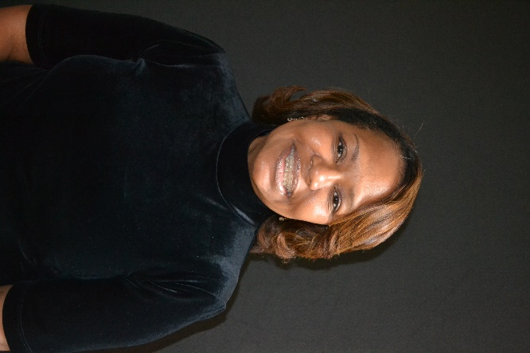
Debbi Saffo Loves the Lord and loves teaching members and the community-at-large how to grow in the image of Christ! Her passion is to assist Christ-followers to define their calling by looking at their relationship with God and reflecting on lessons from past, world views, and how they relate to the church and our present-day culture. Debbi is a business leader and is the president and founder of The NiKhar Group Educational School Improvement, and Workforce Company where she is excited about the opportunity to shine her light in the marketplace. Most importantly, she is a born-again believer of Jesus Christ, and her greatest passion in life is supporting her husband of 34 years, and their two adult children (Nijya & Khari) exalt Christ!

FUN FACTS! I enjoy ALL forms of dance exercise classes, writing educational curriculum guides, traveling, spending time with family, laughing out loud, and encouraging and supporting leaders who have a desire to serve Christ!

